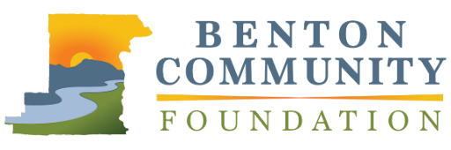
Outstanding Volunteer Fundraiser

APPLICATION

The Benton Community Foundation Philanthropic Achievement Awards recognizes leadership in philanthropy and volunteerism. Outstanding Volunteer Fundraiser will be presented to a volunteer who motivates others to give, commits time and energy without compensation, and shows talent for fundraising strategy, relationship building, and successful resource development. Nominees who have contributed to charitable projects throughout Benton County and surrounding areas are eligible. Limit responses to 1,000 words total.

Nominations must be received by Wednesday, May 31, 2023, at 5:00 PM, via email to Lisa@bcfgives.org or mail to 660 NW Harrison Blvd., Corvallis, OR 97330. Recipients will be announced at the awards event in November.

NOMINEE INFORMATION
Name |  |  | Organization
Street Address |  |  | Phone Number
City | State | Zip | Email
YOUR INFORMATION (if different from above)
Name |  |  | Email

Please describe the nominee and their philanthropic work in the community. Be sure to discuss the contributions they have made in terms of total dollars or in kind support directly cultivated to support the causes they care about.

Please describe the impact that the nominee is making in Benton County to improve the quality of life of Benton County Residents.

Describe the nominee’s approach to leadership in philanthropy. What are some ways they have inspired and encouraged others to give or become involved with the community?

Describe up to three projects the nominee has supported. What were the outcomes of these efforts? Please discuss the tangible impact these projects have made in the community.

