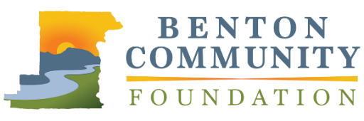
BCF Board of Directors’ Award for
Outstanding Philanthropic Achievement

APPLICATION

The Benton Community Foundation Philanthropic Achievement Awards recognizes leadership in philanthropy and volunteerism. The BCF Board of Directors’ Award for Outstanding Philanthropic Achievement will recognize an exceptional individual or family whose philanthropic leadership has made a significant positive impact on the community. Nominees who have contributed to charitable projects throughout Benton County and surrounding areas are eligible. Please limit responses to 1,000 words total.

Nominations must be received by Tuesday, April 30, 2024, at 5:00 PM, via email to Lisa@bcfgives.org. Recipients will be announced at the awards event in November.

NOMINEE INFORMATION
Name |  |  | Organization
Street Address |  |  | Phone Number
City | State | Zip | Email
YOUR INFORMATION (if different from above)
Name |  |  | Email

Please describe the nominee and their philanthropic work in the community. Be sure to discuss the contributions they have made in terms of time, talent, and/or financial resources to support the causes they care about.

What impact does the nominee hope to achieve through their philanthropy efforts?

Describe the nominee’s approach to leadership in philanthropy. What are some ways they have inspired and encouraged others to give or become involved with the community?

Describe up to three projects the nominee has supported. What were the outcomes of these efforts? Please discuss the tangible impact these projects have made in the community.

